Item name | Item description | Number of face cloths | Colour options
Dog - Small | A face cloth rolled into the likeness of a dog.  This item comes boxed in clear packaging and contains google eyes, felt ears, pom-pom nose, and ribbon bow.  Can be ordered with or without six mini bath bombs. | 1 | Pink
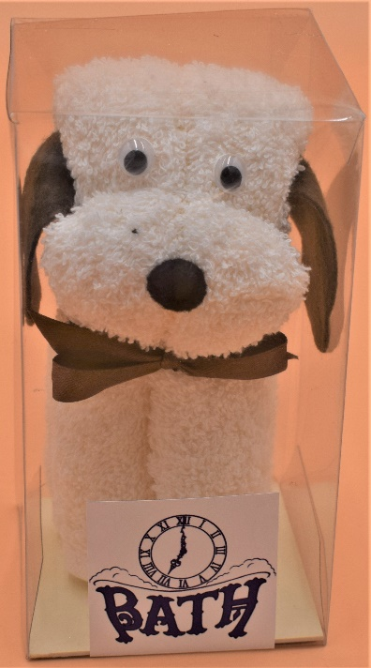 |  | 1 | Navy
 |  | 1 | Teal
 |  | 1 | Wine
 |  | 1 | Cream
 |  | 1 | White
 |  | 1 | Purple
 |  | 1 | Brown
 |  | 1 | Black
 |  | 1 | Grey
Cat | A face cloth rolled into the likeness of a cat.  This item comes boxed in clear packaging and contains google eyes, felt ears, pom-pom nose, and ribbon bow.  Can be ordered with or without six mini bath bombs. | 1 | Pink
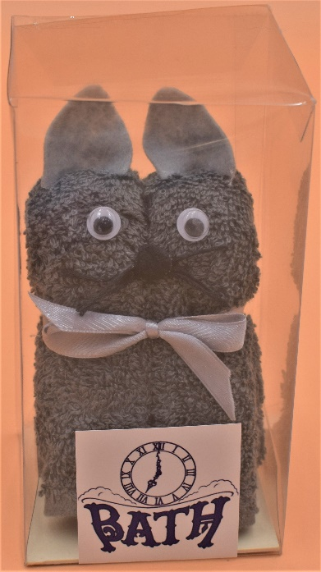 |  | 1 | Navy
 |  | 1 | Teal
 |  | 1 | Wine
 |  | 1 | Cream
 |  | 1 | White
 |  | 1 | Purple
 |  | 1 | Brown
 |  | 1 | Black
 |  | 1 | Grey
Clutch Bag | A face cloth folded into the likeness of a clutch bag.  This item comes boxed in clear packaging and contains 1 soap flower.  Can be ordered with or without six mini bath bombs. | 1 | Pink
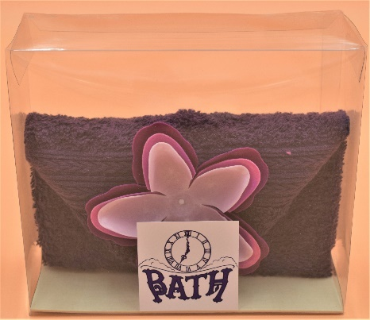 |  | 1 | Navy
 |  | 1 | Teal
 |  | 1 | Wine
 |  | 1 | Cream
 |  | 1 | White
 |  | 1 | Purple
 |  | 1 | Brown
 |  | 1 | Black
 |  | 1 | Grey

Handbag | A face cloth folded into the likeness of a handbag.  This item comes boxed in clear packaging and contains 1 soap flower, and a ribbon handle.  Can be ordered with or without six mini bath bombs. | 1 | Pink
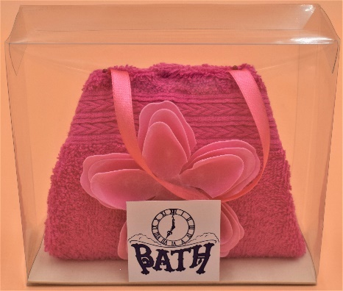 |  | 1 | Navy
 |  | 1 | Teal
 |  | 1 | Wine
 |  | 1 | Cream
 |  | 1 | White
 |  | 1 | Purple
 |  | 1 | Brown
 |  | 1 | Black
 |  | 1 | Grey
Bunny | A face cloth folded into the likeness of a bunny.  This item comes boxed in clear packaging and contains google eyes, and a pom-pom tail and nose.  Can be ordered with or without six mini bath bombs. | 1 | Pink
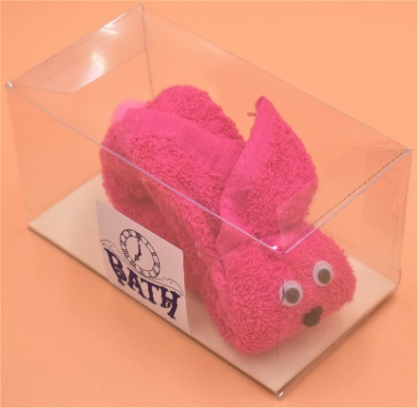 |  | 1 | Navy
 |  | 1 | Teal
 |  | 1 | Wine
 |  | 1 | Cream
 |  | 1 | White
 |  | 1 | Purple
 |  | 1 | Brown
 |  | 1 | Black
 |  | 1 | Grey
Snail | Face cloths folded into the likeness of a snail.  This item comes boxed in clear packaging and contains google eyes, pipe cleaner antennae, and ribbon bow.  Can be ordered with or without six mini bath bombs. | 2 | Pink & White
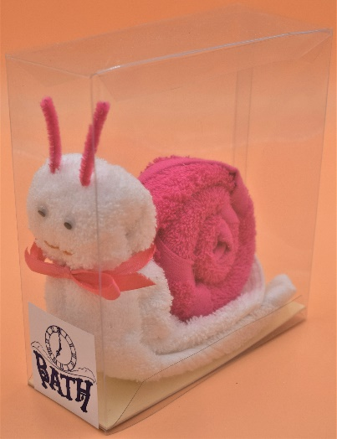 |  | 2 | Navy & White
 |  | 2 | Teal & White
 |  | 2 | Wine & White
 |  | 2 | Cream & White
 |  | 2 | Purple & White
 |  | 2 | Brown & White
 |  | 2 | Black & White
 |  | 2 | Grey & White
Owl | Face cloths rolled into the likeness of an owl.  This item comes boxed in clear packaging and contains google eyes, felt ears, front, beak, wings, and feet, and a ribbon bow.  Can be ordered with or without six mini bath bombs. | 2 | Pink
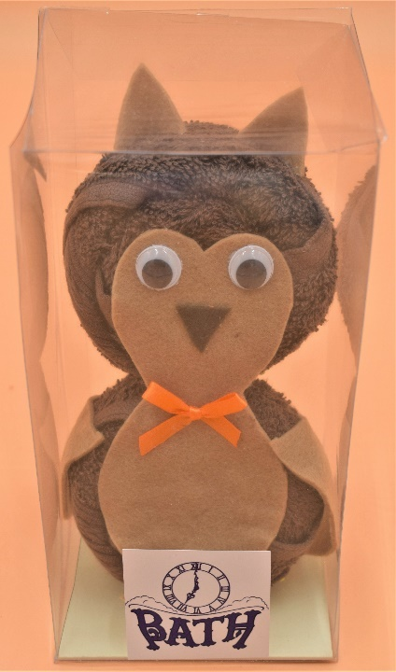 |  | 2 | Navy
 |  | 2 | Teal
 |  | 2 | Wine
 |  | 2 | Cream
 |  | 2 | White
 |  | 2 | Purple
 |  | 2 | Brown
 |  | 2 | Black
 |  | 2 | Grey

Swiss Roll | Face cloths rolled into the likeness of a Swiss roll.  This item comes boxed in clear packaging and contains a ribbon bow.  Can be ordered with or without six mini bath bombs. | 2 | Pink & White
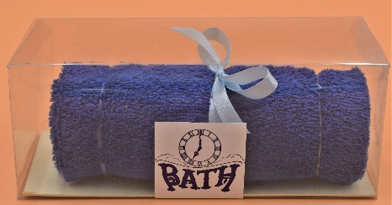 |  | 2 | Navy & White
 |  | 2 | Teal & White
 |  | 2 | Wine & White
 |  | 2 | Cream & White
 |  | 2 | Purple & White
 |  | 2 | Brown & White
 |  | 2 | Black & White
 |  | 2 | Grey & White
Chocolate Cake Slice | Face cloths folded into the likeness of a slice of chocolate cake.  This item comes boxed in clear packaging.  Can be ordered with or without six mini bath bombs. | 2 | Pink & Brown
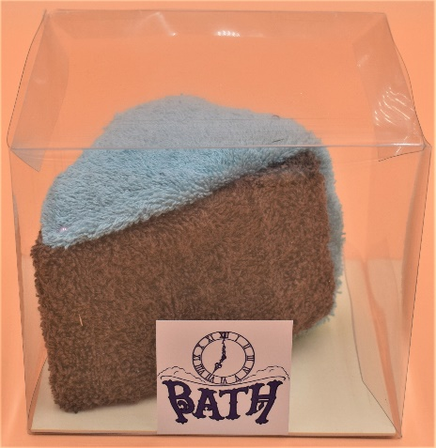 |  | 2 | Navy & Brown
 |  | 2 | Teal & Brown
 |  | 2 | Wine & Brown
 |  | 2 | Cream & Brown
 |  | 2 | White & Brown
 |  | 2 | Purple & Brown
 |  | 2 | Black & Brown
 |  | 2 | Grey & Brown
Victoria Cake Slice | Face cloths folded into the likeness of a slice of Victoria cake.  This item comes boxed in clear packaging and contains a ribbon.  Can be ordered with or without six mini bath bombs. | 2 | Pink & Cream
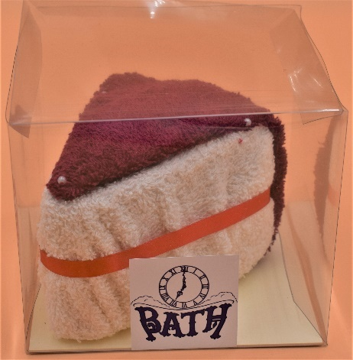 |  | 2 | Navy & Cream
 |  | 2 | Teal & Cream
 |  | 2 | Wine & Cream
 |  | 2 | White & Cream
 |  | 2 | Purple & Cream
 |  | 2 | Brown & Cream
 |  | 2 | Black & Cream
 |  | 2 | Grey & Cream

